15.59: a) As time goes on, someone moving with the wave would need to move in such a way that the wave appears to have the same shape. If this motion can be described by 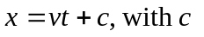a constant (not the speed light),then 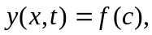
and the waveform is the same to such observer. b) See Problem 15.54. The derivation is completed by taking the second partials,

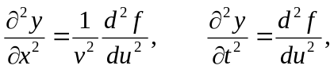

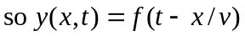is a solution to the wave equation with wave speed . c) This is of the form 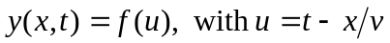and

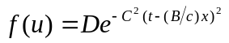,

and the result of part (b) may be used to determine the speed 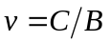immediately.

